Phase 4 - Retail Store Product Demand Analysis
Abstract:
The main aim of our project is to develop a machine learning model (Decision Tree Regression, Gradient Boosting Regression, Random Forest Regression) that forecasts retail store product demand based on pricing, store information, product type, location, and season.
Feature Engineering:
The primary goal of this project is to create a predictive model that can estimate the demand for the product in the market under different pricing strategies. By analyzing historical sales data, the project aims to identify the price point at which the product is perceived as a better deal compared to competitors, leading to increased sales.
Data Collection: Historical sales data
Dataset: https://www.kaggle.com/datasets/chakradharmattapalli/product-demand-prediction-with-machine-learning
Dataset Columns:
The dataset provided for this task includes the following key information:
- Product ID: A unique identifier assigned to each row in the dataset.
- Store ID: Each store is assigned a unique numeric ID (e.g., 8091, 8095) to identify different retail outlets.
- Total Price: The actual selling price after discounts or promotions.
- Base Price: The original price before any discounts are applied.
- Units Sold (Quantity Demanded): The quantity purchased by customers at a given location and season. This is our target variable.
- Season: The season during which the sale occurred (Summer, Winter, Monsoon, Autumn).
- Location: The Indian city where the retail store is located (Mumbai, Delhi, Bangalore, Chennai, Kolkata, Hyderabad, Pune, Jaipur). This is a key feature for demand prediction.
- Product: The name of the product being sold (Rice, Cold Drinks, Umbrella, Sweater, Sunscreen, Raincoat, Ice Cream, Heater, Jacket, Water Bottle).
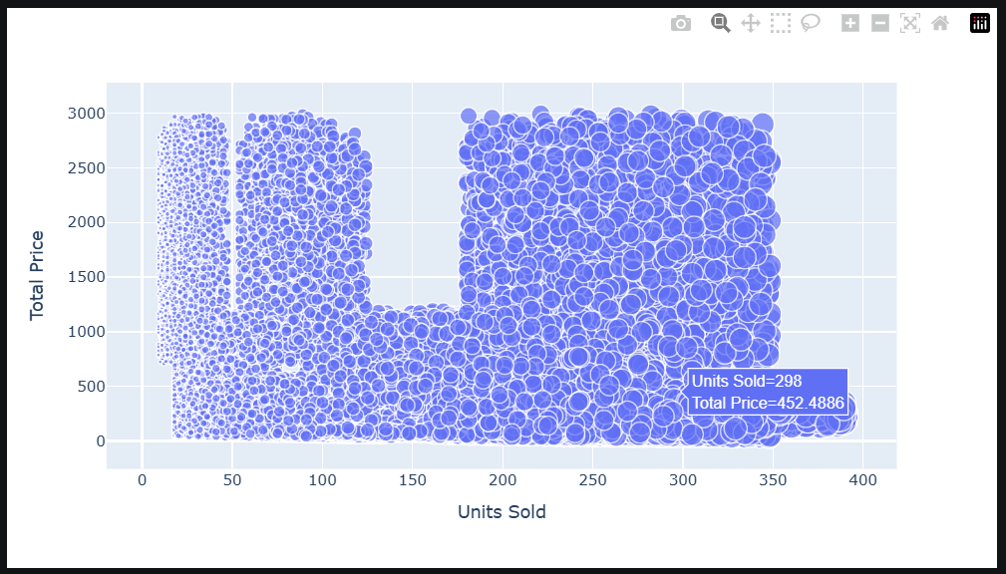
Plot of Total Price vs Units Sold

Training Data:

- Independent Variables (Features):
- Store ID
- Location
- Season
- Product
- Total Price
- Base Price.
- Dependent Variable (Target):
- Units Sold: The number of units of the product sold.
- During the training phase, the machine learning model uses Store ID, Location, Season, Product, Total Price, and Base Price as independent variables to predict the Units Sold.

Testing Data:
Input Features:
a. Store ID b. Location c. Season
d. Product e. Total Price f. Base Price

Output Feature (Prediction):
a. Units Sold: The model predicts units sold based on Location and Season.

Data Correlation:
A correlation matrix is a table showing correlation coefficients between variables. Each cell in the table shows the correlation between two variables. A correlation matrix is used to summarize data, as an input into a more advanced analysis, and as a diagnostic for advanced analyses.
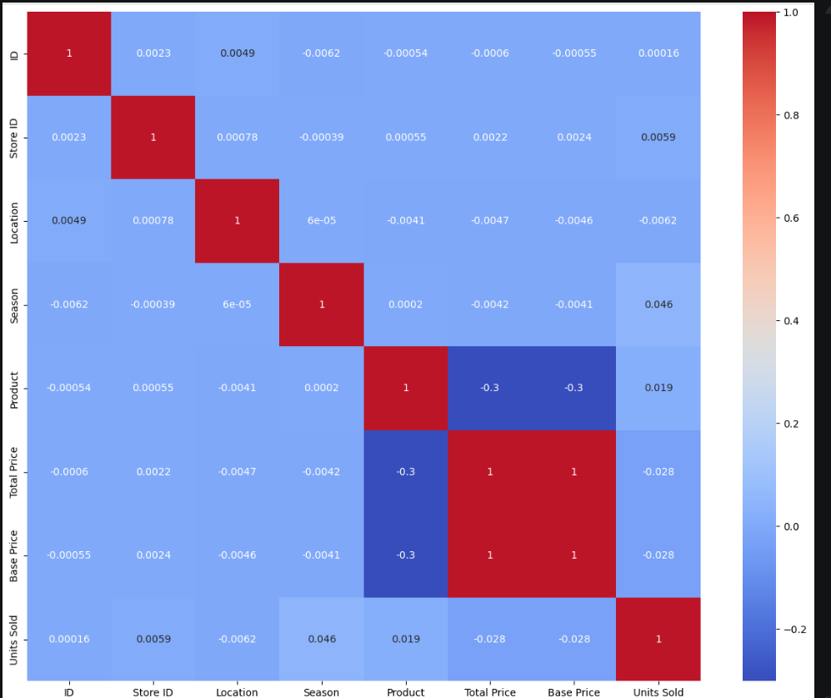
Heat Map for the Correlation Matrix
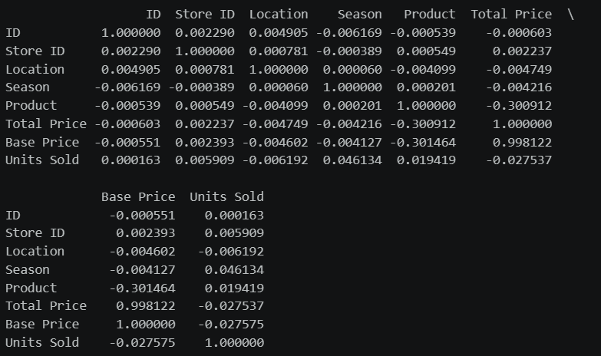
Correlation Matrix
Insights:
- Total Price and Base Price (Correlation: 0.998122: Total Price and Base Price have a very strong positive correlation. This means that there is a strong linear relationship between the total price and the base price of the products. As the base price increases, the total price tends to increase accordingly.
- Total Price and Units Sold (Correlation: -0.027537): Total Price and Units Sold have a moderate negative correlation. This suggests that as the total price of the products increases, the number of units sold tends to decrease. Customers may buy fewer units when the price is higher.

- Base Price and Units Sold (Correlation: -0.140022) : Base Price and Units Sold also have a moderate negative correlation. This indicates that as the base price of the products increases, the number of units sold tends to decrease. This relationship is similar to the one observed with total price.

- Models used:
- Decision Tree Regressor
- GradientBoostingRegressor
- RandomForestRegressor

Model Training:
Training and testing a machine learning model involves several steps.
- Data Splitting: The train_test_split function is used to split the dataset into training and testing sets. This allows us to train the model on one subset of the data and test its performance on another, unseen subset.

train_test_split is a function from the sklearn.model_selection module in scikit-learn. It's a commonly used function for splitting a dataset into two subsets: one for training our machine learning model and the other for testing its performance.

train_test_split Function:
The train_test_split function splits arrays or matrices into random train and test subsets. It takes several parameters, including your features (X) and labels (y), and splits them into four subsets: X_train, X_test, y_train, and y_test.

SOURCE CODE:
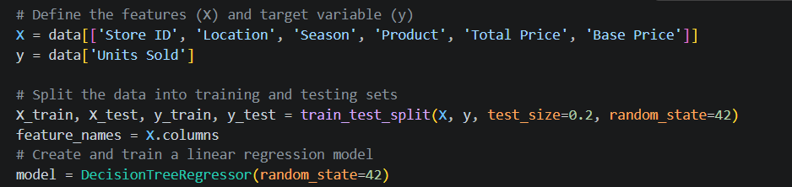
- X is a feature matrix.
- y is the target variable (labels).
- test_size is the proportion of the dataset to include in the test split. In this case, 20% of the data will be used for testing (test_size=0.2).
- random_state is a seed for the random number generator. Providing a specific seed ensures reproducibility. Different seeds will result in different random splits.
After running the code, we will have four datasets:
- X_train: The features for training your model.
- X_test: The features for testing your model.
- y_train: The corresponding labels for training.
- y_test: The corresponding labels for testing.

- Model Initialization: The machine learning model (Random Forest Regressor in this case) is initialized with specified hyperparameters
- Training the Model: The fit function is used to train the model using the training data (X_train and y_train).
- Making Predictions: The trained model is used to make predictions on the test data (X_test). The resulting predictions are stored in the predictions variable.
Accuracy Comparison:
Decision Tree
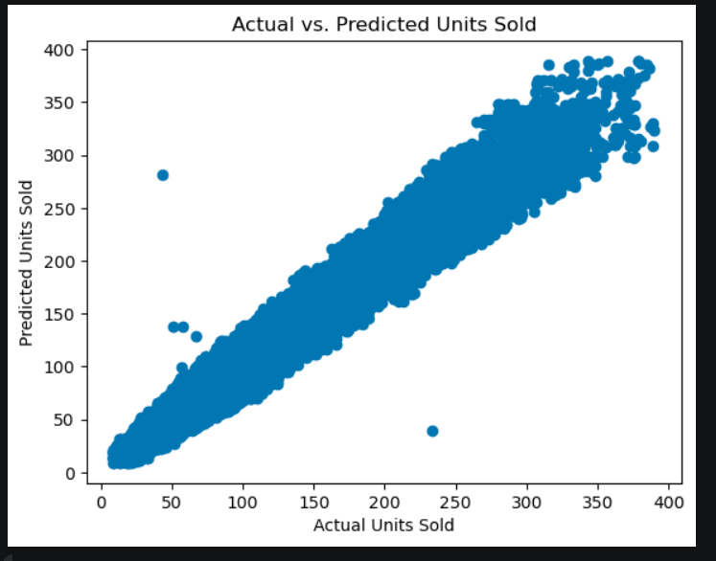
Decision Tree Regression Model:
Plot of Actual Units Sold vs Predicted Units Sold

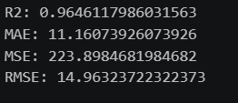

Accuracy Metrics for Decision Tree
Random Forest
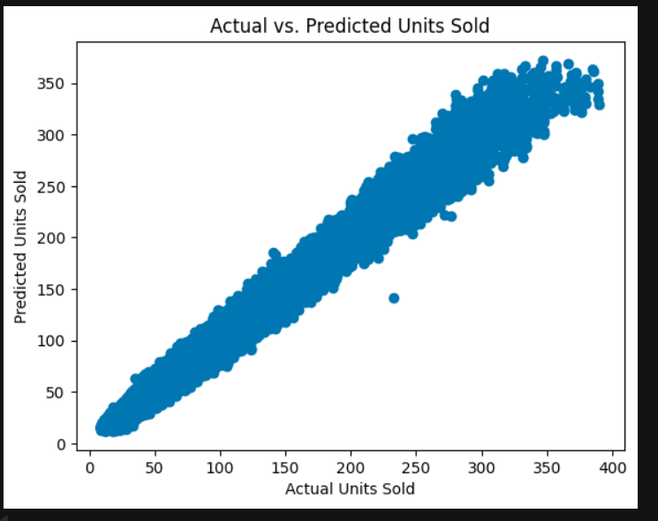
Random Forest Regression Model:
Plot of Actual Units Sold vs Predicted Units Sold

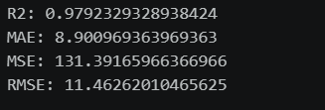
Accuracy Metrics for Random Forest Model

Gradient Boosting
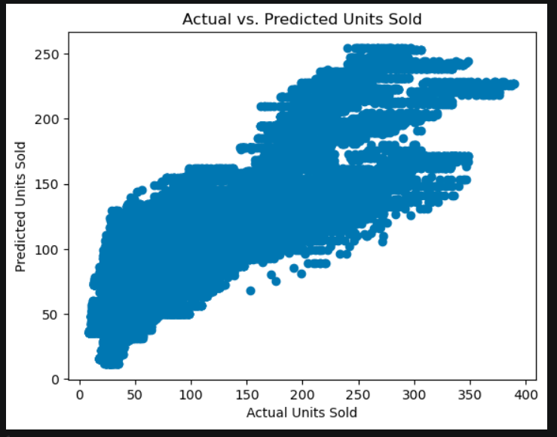
Gradient Boosting Regression Model:
Plot of Actual Units Sold vs Predicted Units Sold

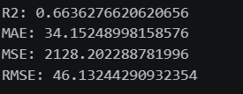

Accuracy Metrics for Gradient Boosting Model

Model Evaluation:

R-Squared(R²)

R², or the coefficient of determination, measures how well a regression model predicts the variance in the dependent variable. It ranges from 0 to 1, where 1 indicates perfect predictions. It's a handy tool to evaluate the goodness of fit in regression analysis.

Mean Absolute Error (MAE):

Mean Absolute Error (MAE) is a metric that calculates the average absolute differences between predicted and actual values in a dataset. It provides a straightforward measure of prediction accuracy. With MAE, the absolute errors are summed up and divided by the number of observations, giving a clear average error value. Unlike some other metrics, MAE treats all errors equally, making it robust and easy to interpret.

Mean Squared Error (MSE):

Mean Squared Error (MSE) measures the average of the squared differences between predicted and actual values. It's a common metric in regression analysis. Squaring the errors emphasizes larger discrepancies, giving a comprehensive view of overall model performance. However, because it squares the errors, it's sensitive to outliers.

Root Mean Squared Error (RMSE):

Root Mean Squared Error (RMSE) is the square root of the Mean Squared Error (MSE). It shares the same intuitive interpretation as the original data's unit, making it more easily understandable. RMSE penalizes large errors, offering a balanced view of prediction accuracy. Like MSE, it's widely used in regression analysis. Lower RMSE values indicate better model performance, and it provides a sense of the average magnitude of prediction errors in the original units of the data.

Comparison of Models

 | Decision Tree | Random Forest | Gradient Boosting
R-squared | 0.9646 | 0.9792 | 0.6636
Mean Absolute Error (MAE) | 11.16 | 8.90 | 34.15
Mean Squared Error (MSE) | 223.89 | 131.39 | 2128.20
Root Mean Squared Error  (RMSE) | 14.96 | 11.46 | 46.13

Conclusion:
In conclusion, after thorough evaluation of Random Forest, Gradient Boosting, and Decision Tree models for product demand prediction, Random Forest emerged as the superior choice with an R-squared score of 0.9792. Its exceptional ability to capture complex patterns and provide accurate forecasts positions it as the most reliable model for predicting future product demand, making it the recommended solution for our problem statement.

